Bash Script Tasks

- Create a bash script tocheck if a directory is available or not.
Script:
#!/bin/bash

DIR="/root/bash-tasks"

if [ -d "$DIR" ]; then
echo "Directory $DIR is available."
else
echo "Directory $DIR is not available."
fi
Output:
[ -d "$DIR" ] :-d checks whether the path is a directory.

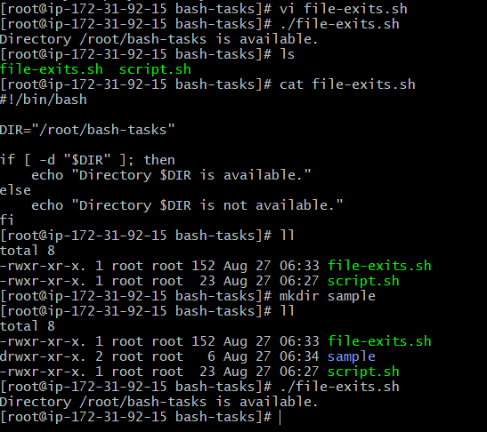

- Create a bash script to create multiple files.
Script:
#!/bin/bash

touch file1.txt
touch file2.txt
touch file3.txt
touch file4.txt
touch file5.txt

echo "5 files created successfully."
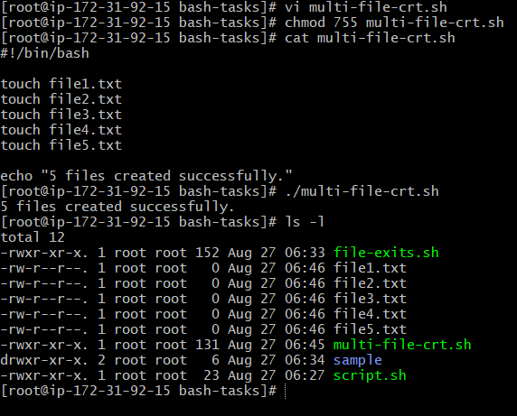
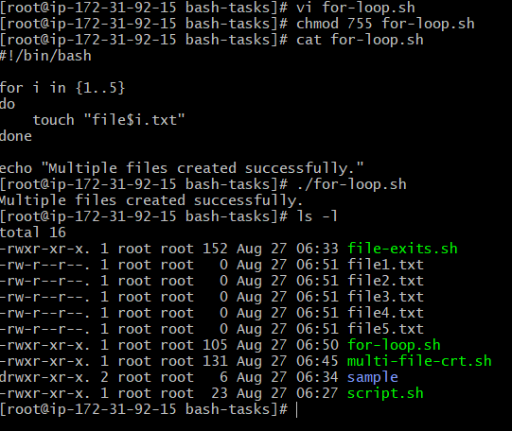

- Create a bash script to take a backup of a directory.

Objective
Create a compressed backup of a directory.
Suppose we want to back up:
/var/www/html

Script
#!/bin/bash

SOURCE="/var/www/html"
BACKUP_DIR="/root/backups"

mkdir -p "$BACKUP_DIR"

DATE=$(date +%Y-%m-%d_%H-%M-%S)

tar -czf "$BACKUP_DIR/html_backup_$DATE.tar.gz" "$SOURCE"

echo "Backup completed successfully."
echo "Backup file: $BACKUP_DIR/html_backup_$DATE.tar.gz"

Important commands
date
gets the current date/time.
tar -czf
creates a compressed .tar.gz archive.

Execute
chmod +x backup.sh
./backup.sh
Check:
ls -lh /root/backups/
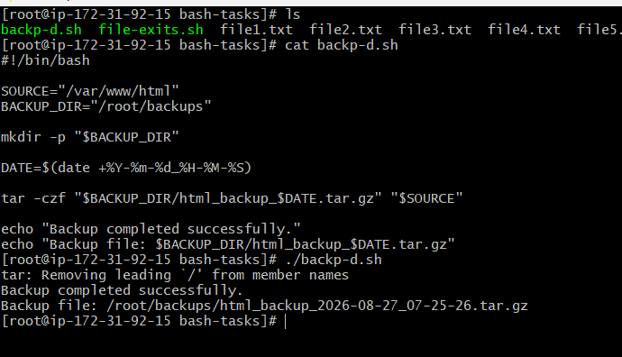

- Create a bash script to install Nginx on an EC2 server.

Objective
Automatically install and start Nginx.
#!/bin/bash

echo "Installing Nginx..."

yum install nginx -y

echo "Starting Nginx..."

systemctl start nginx

echo "Enabling Nginx..."

systemctl enable nginx

echo "Checking Nginx status..."

systemctl status nginx --no-pager

echo "Nginx installation completed."
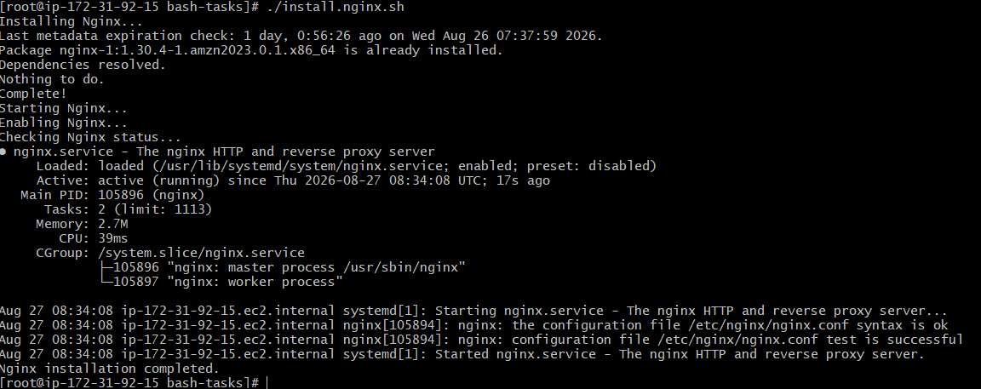

- Create a bash script to install Apache Tomcat on an EC2 server.
Script:
#!/bin/bash

TOMCAT_VERSION="11.0.24"
TOMCAT_DIR="/opt/tomcat"

echo "Installing Java..."

yum install java-17-amazon-corretto -y

echo "Creating Tomcat directory..."

mkdir -p "$TOMCAT_DIR"

cd /tmp

echo "Downloading Tomcat..."

wget https://archive.apache.org/dist/tomcat/tomcat-11/v11.0.24/bin/apache-tomcat-11.0.24.tar.gz

echo "Extracting Tomcat..."

tar -xzf apache-tomcat-11.0.24.tar.gz -C "$TOMCAT_DIR" --strip-components=1

echo "Starting Tomcat..."

"$TOMCAT_DIR/bin/startup.sh"

echo "Tomcat installation completed."

echo "Checking Tomcat port..."

ss -tlnp | grep :8080

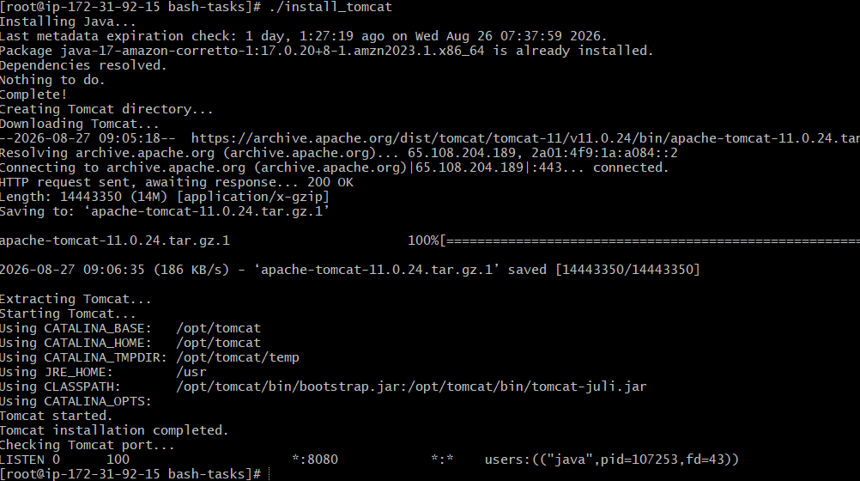
- Create a bash script to check if the Nginx service is running, if not running then script should start the service.
If Nginx is running:
Nginx is running.
If it is stopped:
Nginx is not running. Starting Nginx…
#!/bin/bash
if systemctl is-active --quiet nginx
then
echo "Nginx is running."
else
echo "Nginx is not running."
echo "Starting Nginx..."
systemctl start nginx
if systemctl is-active --quiet nginx
then
echo "Nginx started successfully."
else
echo "Failed to start Nginx."
fi
fi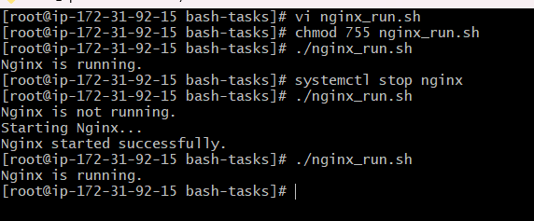

- Create a bash script for acalculator.

Objective
Perform basic mathematical operations.
#!/bin/bash

echo "Enter first number:"
read num1

echo "Enter second number:"
read num2

echo "Choose operation:"
echo "1. Addition"
echo "2. Subtraction"
echo "3. Multiplication"
echo "4. Division"

read choice

case $choice in

1)
result=$((num1 + num2))
echo "Result = $result"
;;

2)
result=$((num1 - num2))
echo "Result = $result"
;;

3)
result=$((num1 * num2))
echo "Result = $result"
;;

4)
if [ "$num2" -eq 0 ]; then
echo "Cannot divide by zero."
else
result=$((num1 / num2))
echo "Result = $result"
fi
;;

*)
echo "Invalid choice."
;;

esac
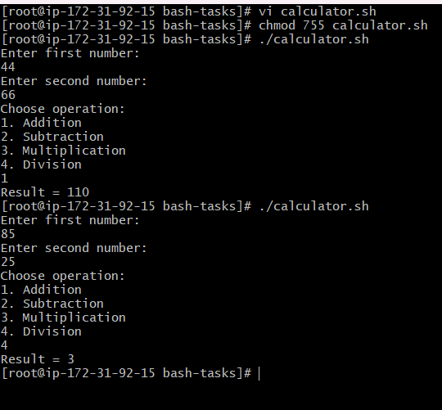

- Create a bash script to check if a directory exists, if not then create a directory.
This is slightly different from Task 1.
Task 1 only checks.
This task checks + creates.
#!/bin/bash
DIR="/opt/myapp"

if [ -d "$DIR" ]; then
echo "Directory already exists: $DIR"
else
echo "Directory does not exist."
echo "Creating directory..."

mkdir -p "$DIR"
echo "Directory created successfully: $DIR"
fi
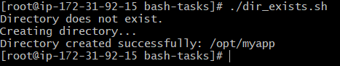

- Create a bash script to delete the last 3 lines of a file.
#!/bin/bash
FILE="test.txt"
if [ ! -f "$FILE" ]; then
echo "File does not exist."
exit 1
fi
head -n -3 "$FILE" > "$FILE.tmp"
mv "$FILE.tmp" "$FILE"
echo "Last 3 lines deleted successfully."

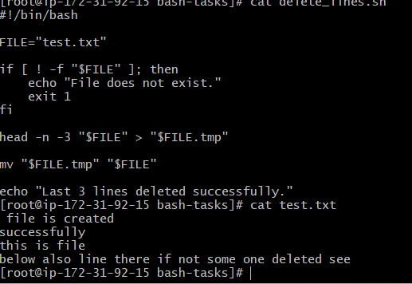
- Bash script to monitor cpu and if it is more than 80% then send email notification.
Check CPU utilization.
If CPU usage exceeds 80%, send an email notification.
A simple Amazon Linux approach is:
#!/bin/bash
THRESHOLD=80
EMAIL="psschandrashekar@gmail.com"

CPU=$(top -bn1 | awk '/Cpu\(s\)/ {print 100 - $8}')

CPU_INT=${CPU%.*}

echo "Current CPU usage: $CPU%"

if [ "$CPU_INT" -gt "$THRESHOLD" ]; then

echo "CPU usage is above 80%: $CPU%" \
| mail -s "CPU Alert on $(hostname)" "$EMAIL"
echo "CPU alert email sent."
else
echo "CPU usage is normal."
fii
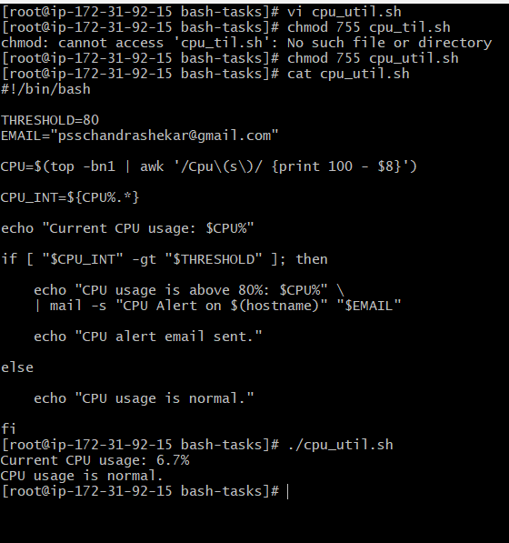

- Bash script to monitor disk space and if it is more than 80% then send email notification.
#!/bin/bash
THRESHOLD=80
EMAIL="psschandrashekar@gmail.com"
DISK=$(df / | awk 'NR==2 {print $5}' | tr -d '%')
echo "Current disk usage: $DISK%"
if [ "$DISK" -gt "$THRESHOLD" ];
then
echo "Disk usage is above 80%: $DISK%" \
| mail -s "Disk Space Alert on $(hostname)" "$EMAIL"
echo "Disk alert email sent."
else
echo "Disk usage is normal."
fi
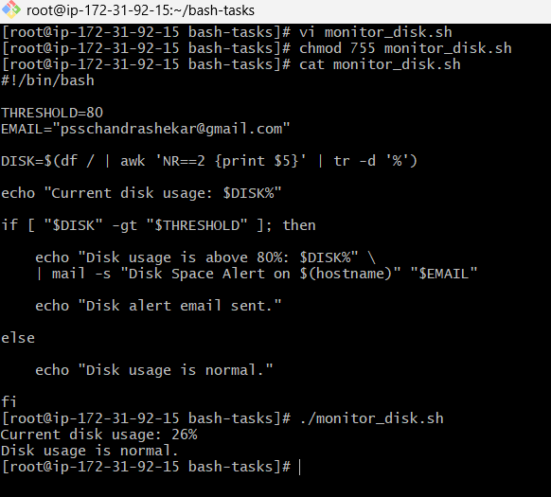
- Bash script to monitor memory and if it is more than 80% then send email notification.

#!/bin/bash

THRESHOLD=80
EMAIL="your-email@example.com"

MEMORY=$(free | awk '/Mem:/ {
printf "%.0f", ($3/$2)*100}')

echo "Current memory usage: $MEMORY%"

if [ "$MEMORY" -gt "$THRESHOLD" ]; then

echo "Memory usage is above 80%: $MEMORY%" \
| mail -s "Memory Alert on $(hostname)" "$EMAIL"

echo "Memory alert email sent."

else

echo "Memory usage is normal."

fi

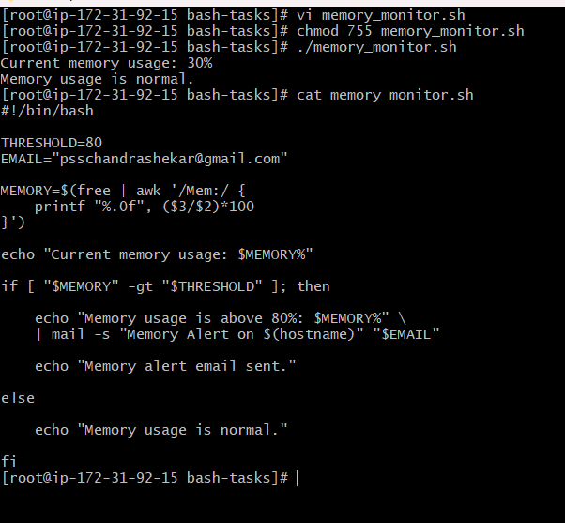
Exercise: Crontab Entries
- April 5th Midnight
- 5th of Every November, January, Juneif it is a Thursday
- At05 and 27th minutesof9, 10, 11hours every day
- 34 minutesof9th houron15th August
- Every midnight
- Every Weekend (Saturday night 11:59 PM)
- After every reboot
First open crontab:
crontab -e
The format is:
MINUTE HOUR DAY MONTH DAY_OF_WEEK COMMAND
Remember:
┌──────── minute (0-59)
│ ┌────── hour (0-23)
│ │ ┌──── day (1-31)
│ │ │ ┌── month (1-12)
│ │ │ │ ┌─ day of week (0-7)
│ │ │ │ │
* * * * * command

1. April 5th Midnight
Midnight = 00:00
April = 4
5th day:
0 0 5 4 * /path/to/script.sh
Meaning:
00 minutes
00 hour
5th day
April
any day of week

2. 5th of November, January, June if Thursday
This one is important because both day-of-month and day-of-week are specified.
0 0 5 1,6,11 4 /path/to/script.sh
Here:
1 = January
6 = June
11 = November

4 = Thursday
Cron's day-of-month/day-of-week behavior can be confusing: in standard cron implementations, when both fields are restricted, they are generally treated as an OR, not an AND. So this entry can run on every Thursday in those months, not only when the 5th is Thursday.
If the requirement truly means "the 5th of January/June/November only when that date is Thursday", use a script condition instead, e.g.:
0 0 5 1,6,11 * /path/to/check_thursday.sh
with:
#!/bin/bash

if [ "$(date +%u)" -eq 4 ]; then
/path/to/actual_script.sh
fi
That's the safer way to implement the exact requirement.

3. 05 and 27 minutes of 9, 10, 11 hours every day
5,27 9,10,11 * * * /path/to/script.sh
This runs at:
09:05
09:27
10:05
10:27
11:05
11:27
every day.

4. 34 minutes of 9th hour on 15th August
34 9 15 8 * /path/to/script.sh
Meaning:
09:34 AM
15 August

5. Every midnight
0 0 * * * /path/to/script.sh

6. Every weekend — Saturday 11:59 PM
59 23 * * 6 /path/to/script.sh
Here:
59 = minute
23 = 11 PM
6 = Saturday

7. After every reboot
Use:
@reboot /path/to/script.sh
Example:
@reboot /root/bash-tasks/start_services.sh

